w | COMIRB Protocol

COLORADO MULTIPLE INSTITUTIONAL REVIEW BOARD

CAMPUS BOX F-490 TELEPHONE: 303-724-1055 Fax: 303-724-0990

Protocol #:
Project Title: Attributes of residency applicants to OBGYN: A model to predict matching success
Principal Investigator: Tyler Muffly, MD
Version Date: 5/1/2019

I. Hypotheses and Specific Aims:

HYPOTHESIS
Our hypothesis is that it is feasible to develop a statistical model to predict matching success for applicants to obstetrics and gynecology. The model will be an objective measure to be used by residency applicants in self-selection and by residency directors in stratifying candidates for interview and ranking.

OBJECTIVE
To develop a prediction model, illustrated as a nomogram, for predicting the likelihood of success for residency applicants to OBGYN using baseline applicant characteristics.

SPECIFIC AIMS
1) Construct a statistical prediction model that determines the probability of successfully matching in a OBGYN residency for a given set of applicant characteristics using data available from the Electronic Resident Application Service (ERAS) regarding baseline applicant characteristics (predictors) and matching status (outcome).

2) Assess the accuracy of the model obtained from Specific Aim 1 using a bootstrapping technique and ERAS data.

3) Create a nomogram based on the statistical model in Specific Aim 1 that can be easily used for decision-making by both residency applicants and residency program directors. (The completion of this aim is dependent on the success of Specific Aim 2.)

4) To evaluate if the nomogram is better than chance at predicting matching success.

II. Background and Significance:
The residency matching process is a complex system that allows for applicants to apply, interview, and match into a residency program.(1) Currently, residents are selected by unstructured qualitative methods that rely on different variables and the intuition of the residency director and interviewers. An increasing number of residency applicants also means program directors have less time to evaluate each application objectively. Moreover, a limitation of the matching system is that applicants are not aware of which applicant characteristics are more likely to aid in a successful match. A tool that could provide quantitative data on predicting a successful match would be particularly important for applicants and residency directors. Applicants invest a considerable amount of money and time in the matching process, regardless of whether or not they match. Thus, the decision to make this investment should be considered carefully and in light of the applicant-to-position ratio. The financial investment of applicants matching approached $4,000.

Few studies have addressed associations between applicant characteristics and residency matching success.(2) Applicant age, gender, clinical research experience, interview skills, medical school honorary society membership, chief resident status, and letter from a “nationally-known” attending physician in the desired specialty appear to have a linear correlation with matching success.(3) Nomograms using non-linear models are a well-recognized technique used to enhance the prediction for individual patients with clinical diseases such as prostate cancer. These statistical techniques have the potential to show promise as an analytical tool for improving the OBGYN matching process. In this study, the authors demonstrated the ability of the nomogram to predict the probability that a man with clinically localized prostate cancer will survive his disease for 120 months if the cancer is not treated with curative intent immediately.(4) Using this probability model, they were able to show how multiple individual patient characteristics affect one another and how this model is a better predictor than a clinician’s guess (Figure 1). Because multiple variables are involved in the matching process, a nomogram might be equally effective in ranking and selecting applicants, thus providing quantitative data for applicants and directors. Figures 2 and 3 demonstrate algorithms utilizing a nomogram during the application process from the residency director’s (Figure 2) and the applicant’s (Figure 3) point of view. A search of the MedLINE database confirms that there are currently no nomograms available to predict matching success for medical students, residents, or fellows. Our study aims to remedy this deficiency.

SIGNIFICANCE
Applicants and residency program directors currently lack an objective method to determine the likelihood of a successful residency match. This information can be useful when deciding to apply or when comparing candidates. Several investigators have examined decision aids in clinical medicine. Decision aids, which can include prediction models, have been shown to improve knowledge and affect decision-making behavior.(5) There are no instruments to allow for prediction of matching success. In a decision aid capacity, the proposed nomogram can help applicants address the simple question, “What are my chances of matching?” This is a critical question, as applicants need these predictions, tailored to them, of all benefit (matching) and harm (not matching) for which they are at risk.

Figure 1: Pretreatment nomogram that predicts 5-year probability of metastasis following three-dimensional conformal radiation therapy for localized prostate cancer.
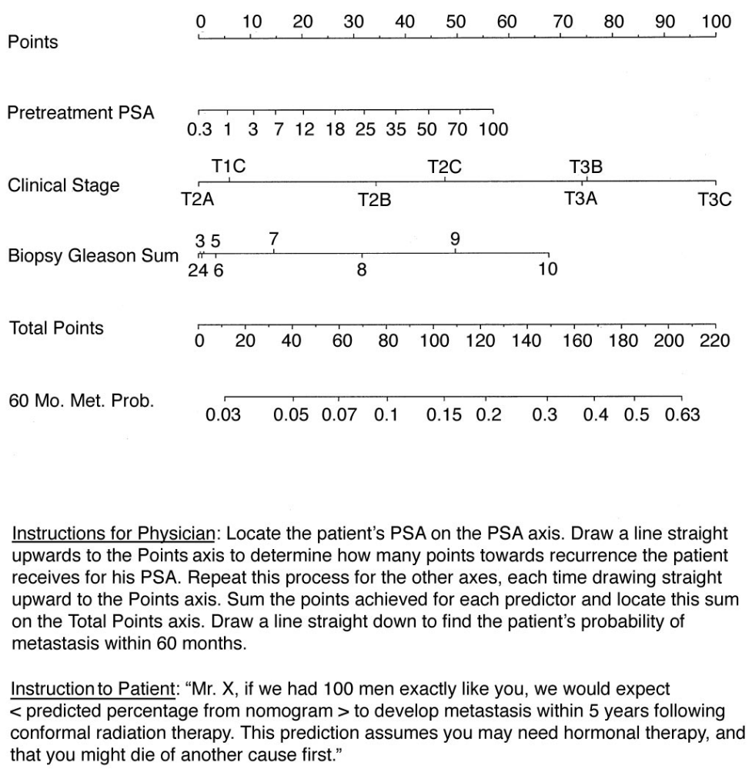

Figure 2: The current selection process for applicants to OBGYN. The nomogram would allow for program directors to select a high quality applicant pool objectively for interviewing and ranking.

Program Director decides to select a new resident and enrolls in the Match
Review Applications from Medical Students
Invite Applicants for Interview
Interview Applicants
Applicants ranked by Program Director
Match Outcome
Decision made to interview
applicant augmented by nomogram
Decision to rank applicant augmented by nomogram
Interview
Ranking
Results

Figure 3: The current selection process for applicants to the surgical sub-specialty residencys. The nomogram would allow for candidates to predict the likelihood of matching and help formulate how competitive they are when formulating a rank order list.

Applicant decides to apply to residency and enrolls in the Match
Apply to individual Fellowship Programs via Electronic Residency Application Service
Invitation for Interview
Interview at a Residency Program
Applicant ranks each Residency Program
Match Outcome
Candidate Contributions:
Candidate Demographics
Letters of recommendation
Service examination scores
Research experiences
Decision to rank high or low competition residency programs augmented by nomogram
Interview
Ranking
Results
Self-selection and decision made to apply for residency in OBGYN based on nomogram

Figure 4: Receiver operating characteristic curves (ROC) for residency directors as a group, and the nomogram. The ROC curve is a visual representation of the tradeoff between the sensitivity and specificity of a diagnostic test. This curve describes the inherent predictive ability of the test. Each point along the curve corresponds to the sensitivity and specificity for that test threshold. In our study, the curve describes the sensitivity and specificity of the nomogram at different levels of likelihood of successfully matching. The area under the ROC curve (AUC) is a value measurement that allows us to compare the predictive ability of two tests. If the AUC is .5, then the curve is approximately a straight line, and the test is no better than a flip of a coin in predicting the desired outcome. However, if the AUC is 1.0, then the test is perfect and correctly identifies all the true positives and true negatives. Sensitivity indicates the proportion of applicants successfully matched who were predicted to successfully match. Specificity indicates the proportion of applicants not matched who were predicted not to match. For the example below, the AUC for the nomogram was .72, and the AUC for clinicians as a group was .54 (P < .01).

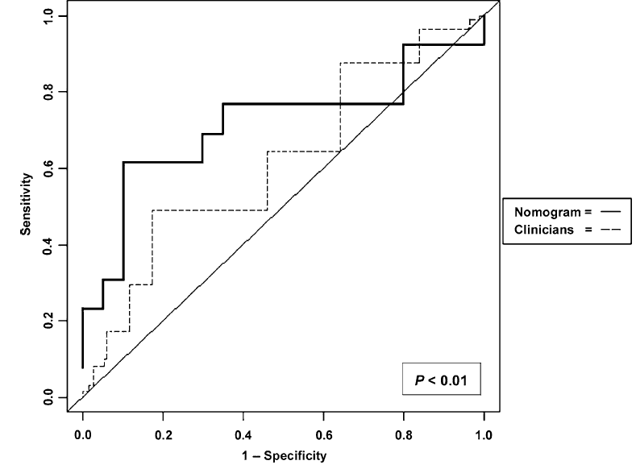

III. Preliminary Studies/Progress Report:

IV. Research Methods

- Outcome Measure(s):
Our overall objective is to create a probability of matching into a OBGYN residency nomogram for applicants and residency directors. We feel that a widely applicable, inexpensive, and statistically sound nomogram for predicting matching success should be considered as an integral part of the ongoing research efforts to improve applicant self-selection and to provide residency directors with an effective means of stratifying applicants.

- Description of Population to be Enrolled:
Export of medical student application data from the AAMC program director workstation.

- Study Design and Research Methods
Retrospective review of data to find if there are predictors of matching.

Variables:
- Match Status
- ACLS certification
- Age (years)
- Alpha Omega Alpha
- Count of Non-peer reviewed online publications
- Count of oral presentations
- Count of other articles
- Count of peer reviewed book chapters
- Count of peer reviewed journal article abstracts
- Count of peer reviewed journal article abstracts other than published
- Count of peer reviewed online publication
- Count of poster presentation
- Count of poster presentation
- Count of scientific monographs
- Couples match
- Gender
- Medical education or training interrupted
- Medical degree
- Military service obligation
- Number of positions offered
- US or Canadian Applicant
- USMLE Step 1 Score
- Visa Sponsorship needed
- White vs. Non-White
- Year of residency match

D. Description, Risks and Justification of Procedures and Data Collection Tools:
The main risk is data being released.

E. Potential Scientific Problems:
A lack of predictors or predictors that appear to be discriminatory.

F. Data Analysis Plan:
We plan to analyze the data after safely storing it in the Denver Health RedCAP. The data will be analyzed using the R statistics software on a computer located at the University of Colorado.

The analysis will follow strategies recommended in the text “Regression Model Strategies”(9) and utilize the packages Hmisc and rms by the same author. Data will be cleaned and then visualized to test for skew. We plan to allow for relaxed cubic splines in order that linearity is not required for continuous variables. Data will be imputed because missing values are a common problem in data science. Deleting rows with missing values can be costly, and simply imputing the corresponding mean or median is probably not the most accurate imputation one can make. The function aregImpute multiply imputes every missing value in the data and thus also creates multiple data sets. Afterwards, fit.mult.impute calculates averaged coefficients, based on the created data sets, with imputation corrected variances. Finally the model will be built using backwards stepwise logistic regression. Models will be tested using the concordance index or the c-index. This is a standard performance measure for model assessment in logistic regression. The function calculates the fraction of all pairs of subjects who’s outcome can be ordered such that the subject with the actual outcome survived. Finally the model would be compared to the predictions of residency directors and clerkship directors about the probability of matching.

G. Summarize Knowledge to be Gained:
A nomogram would also have several practical applications for residency directors. Residency directors are burdened by a process that requires screening numerous electronic applications to select and rank candidates. Currently, the way applicants are ranked is by residency directors intuitively weighing the candidate’s application. While intuition is helpful to supplement the selection process, numerous biases interfere with the ability to calculate probabilities mentally.(6) One of these many biases is heuristics used for coping with the large amount of data regarding a selection decision. Throughout the prediction process, these biases undermine predictive accuracy of who will match into residency. To be clear, we see the nomogram used as a supplement to the interview process instead of as a replacement.

H. References:

- National Residency Matching Program. How the NRMP Process Works. Available at: http://www.nrmp.org/about_nrmp/how.html. Accessed on: May 22, 2010.
- Muffly TM, Penick ER, Tang F, Bonham AJ, Smith RP, Hill RF, Blandon RE. Factors used by female pelvic medicine and reconstructive surgery residency directors to select their fellows. Int Urogynecol J Pelvic Floor Dysfunct. 2010 Mar;21(3):349-52.
- Marciani RD, Smith TA, Heaton LJ, Marciani RD, Smith TA, Heaton LJ. Applicants’ opinions about the selection process for oral and maxillofacial surgery programs. Journal of Oral & Maxillofacial Surgery 2003 May;61(5):608-14.
- Kattan MW, Cuzick J, Fisher G, Berney DM, Oliver T, Foster CS, Møller H, Reuter V, Fearn P, Eastham J, Scardino PT; Transatlantic Prostate Group. Nomogram incorporating PSA level to predict cancer-specific survival for men with clinically localized prostate cancer managed without curative intent. Cancer. 112(1):69-74, 2008 Jan 1.
- O'Connor AM et al. (1999) Do shared decision making programs work? A systematic overview. Med Decis Making 11: 523.
- Hogarth RM. Judgement and choice: the psychology of decision. Vol 2. New York: Wiley; 1987.
- Kattan MW, Cuzick J, Fisher G, Berney DM, Oliver T, Foster CS, Møller H, Reuter V, Fearn P, Eastham J, Scardino PT; Transatlantic Prostate Group. Nomogram incorporating PSA level to predict cancer-specific survival for men with clinically localized prostate cancer managed without curative intent. Cancer. 112(1):69-74, 2008 Jan 1.
- National Residency Matching Program. Results and Data Specialties Matching Service 2008 Appointment Year NRMP. 2008 http://www.nrmp.org/data/resultsanddatasms2009.pdf, Table 1, Page 6, NRMP.
- Harrell FE, Jr, Lee KL, Mark DB. Multivariable prognostic models: Issues in developing models, evaluating assumptions and adequacy, and measuring and reducing errors. Stat Med. 1996;15:361-387.

